We do not attempt to identify plants from common names: it is a minefield into which we do not need to venture!

61.10.31
To Richard Heales
S61/8678, unit 749, VPRS 1189/P inward registered correspondence, VA 475 Chief Secretary's Department, Public Record Office, Victoria.

Melbourne bot. & zool. Garden,
31. Oct. 1861.
Sir
I have the honor of submitting to you a brief report on the work and proceedings in this establishment during the month of October.
The wet weather combined with the heat of intervening days caused so rapid a growth of weeds, that the utmost attention was needed to subdue them, the Sorrel, the Cape Cryptostemma and several other herbs now overpowering much of the vegetation in the reserves, are invading the gardens from all sides. By endeavoring to prevent these plants from seeding around the gardens we may hope to render the labor of keeping the gardens free of weeds one of not increasing difficulty. Weeding in the extensive nurseries required also much attention, especially as so many valuable young plants and small seedlings are harbored there. A rather careful calculation of what the nurseries now contains gives approximately 200,000 plants, including a remarkably valuable lot of young pines; the greater portion of all these plants can be rendered during the next & the following season available for public Institutions. Several species of American Walnuts, new kinds of Rhubarb and other useful plants have been raised during the month. We sent two glass cases with living plants abroad, one to the botanic Garden of Java, the other to Calcutta. The most valuable contributions received were: an extensive collection of seeds of Himalaian plants from the Rev. Sam. Smith of Castlemaine; a fine set of Scandinavian French and South African Algae, presented by Professor Dr. Areschoug of Upsala; dried plants collected in the Indian Archipelago and transmitted from Utrecht by Professor Dr Miquel; a large consignment of seeds of the Cabbage palm and of the Seaforthia palm from A. Ralston Esq. of Sydney. The latter seeds are to a great extent required for interchange with the acclimatisation Society of France. To the same Society we transmitted pr "Kent" a pair of native porcupines. The flock of Chinese Sheep now at the Royal park has increased by 6.
Iron seats are placed as well in the gardens as into the rotunda beyond it.
The two Conservatories received coatings of paint.
In hours available from other duties the work on the Victorian plants receives due attention, the order of Mallow worts having passed the press during the month.
In conclusion I beg to express my grateful acknowledgement not only for the liberal support which this establishment enjoyes in the estimates for 1862, but also for the kindness of the Government in adding the northern basaltic reserve to the area of this garden.
I have the honor to be,
Sir,
your most obedient and humble servant
Ferd. Mueller.

The honorable the Chief Secretary
&c &c &c

Cryptostemma

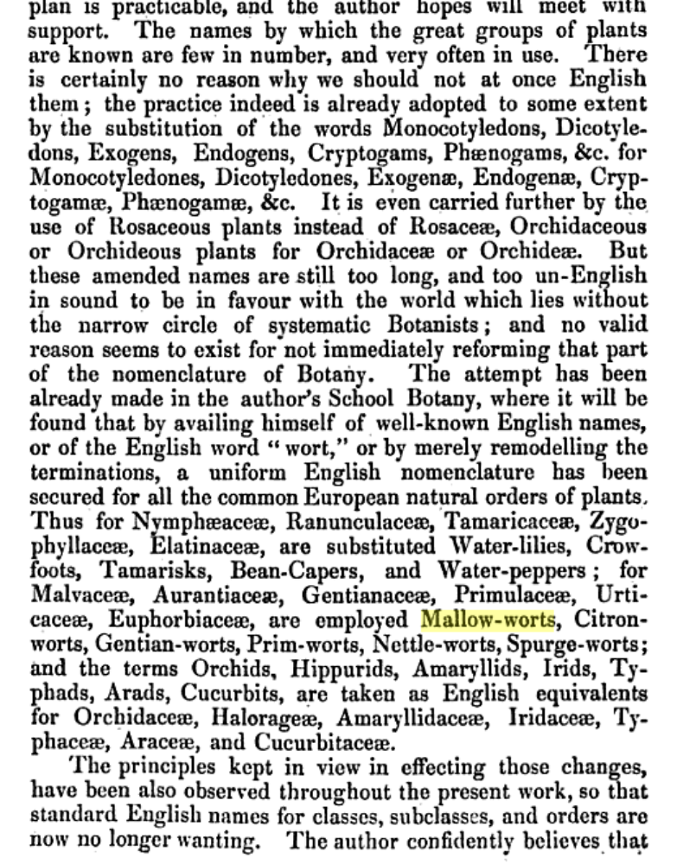

can these weeds be identified? HC: Rumex acetpse;;a = sorrel. Cryptpste,,a calendulaceum = Cape Cryptostemma - Cape weed.
Presumably Livistona australia and what? See B95.13.02. HC: probably Seaforthia elegans.
what order is this? HC: I don't understand this. Mallows are from the family Malvaceae. A wort is a plant used medicinally. M may mean the Malvaceae from Pl. Indig. had been printed but that doesn't fit nicely with the sections of the book and without a detailed publication schedule it would be impossible to tell if this is what he means. I don’t see why Helen thinks that the this doesn't fit with the printing of Plants Indig. As far as I know it was not published in fascicles; thereis certainly no indication in the M bibliog that it was.. The Malvacea occupy the last two pages of gathering U and all of gathering X (there is no gathering V), Surely M means that the Mallows are finished. Mallow Worts was a "common name" used for the Malvaceae, and indeed Lindley proposed that it be used as the formal English name for the Malvaceae in 1845: See attached note on next page. Note should be: Malvaceae occupy the last 3 pages of gathering U and all of gathering X (there is no V) of B62.03.03, i.e., pp 158-168.
See M to R. Heales, 4 October 1861.
MS file annotation by Heales, 8 November 1861: 'Read'.

